**CPQ and TTT Planning Sheet**





**Title:**

Making ConnectionsC:\Documents and Settings\ddycha\Local Settings\Temporary Internet Files\Content.IE5\1TTJYVJL\MCj03299300000[1].wmf

**Write your CPQ (comprehension purpose question) here.**

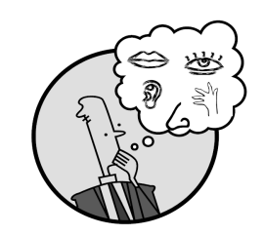Creating Mental Images

**Vocabulary words:**

Making Inferences & PredictingC:\Documents and Settings\ddycha\Local Settings\Temporary Internet Files\Content.IE5\PICBQBTG\MCj02503920000[1].wmf

**Think Turn Talk Question & page #**

Asking & Answering QuestionsC:\Documents and Settings\ddycha\Local Settings\Temporary Internet Files\Content.IE5\D3TFXU7L\MCj03841720000[1].wmf

**Vocabulary words:** (multiple meaning, academic vocabulary)

**Think Turn Talk Question & page #**

Determining Importance & Summarizing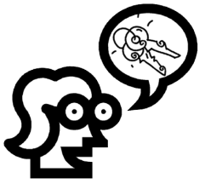

**Think Turn Talk Question & page #**

Monitoring & ClarifyingC:\Documents and Settings\ddycha\Local Settings\Temporary Internet Files\Content.IE5\PICBQBTG\MCj04242520000[1].wmf

