**3. Climax**

**When does the main character face their problem? This is the turning part of the story… things will never be the same for the character.**

___________________________________________________

___________________________________________________

___________________________________________________

___________________________________________________

___________________________________________________

___________________________________________________

___________________________________________________

___________________________________________________

___________________________________________________

___________________________________________________

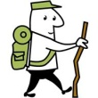

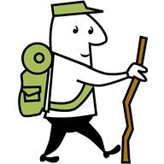

**Point of View – 1st or 3rd person?**

**6. Conflict**

**What is the major problem in the story?**

1. **Exposition**

**Who are the main characters in the beginning of the story?**

**What is the setting in the beginning of the story?**

**5. Resolution:**

**What happens at the VERY end of the story?**

**2. Rising Action**

**What events happen after the exposition and before the climax?**

**4. Falling Action:**

**What happens immediately after the climax?**