Word of the Week
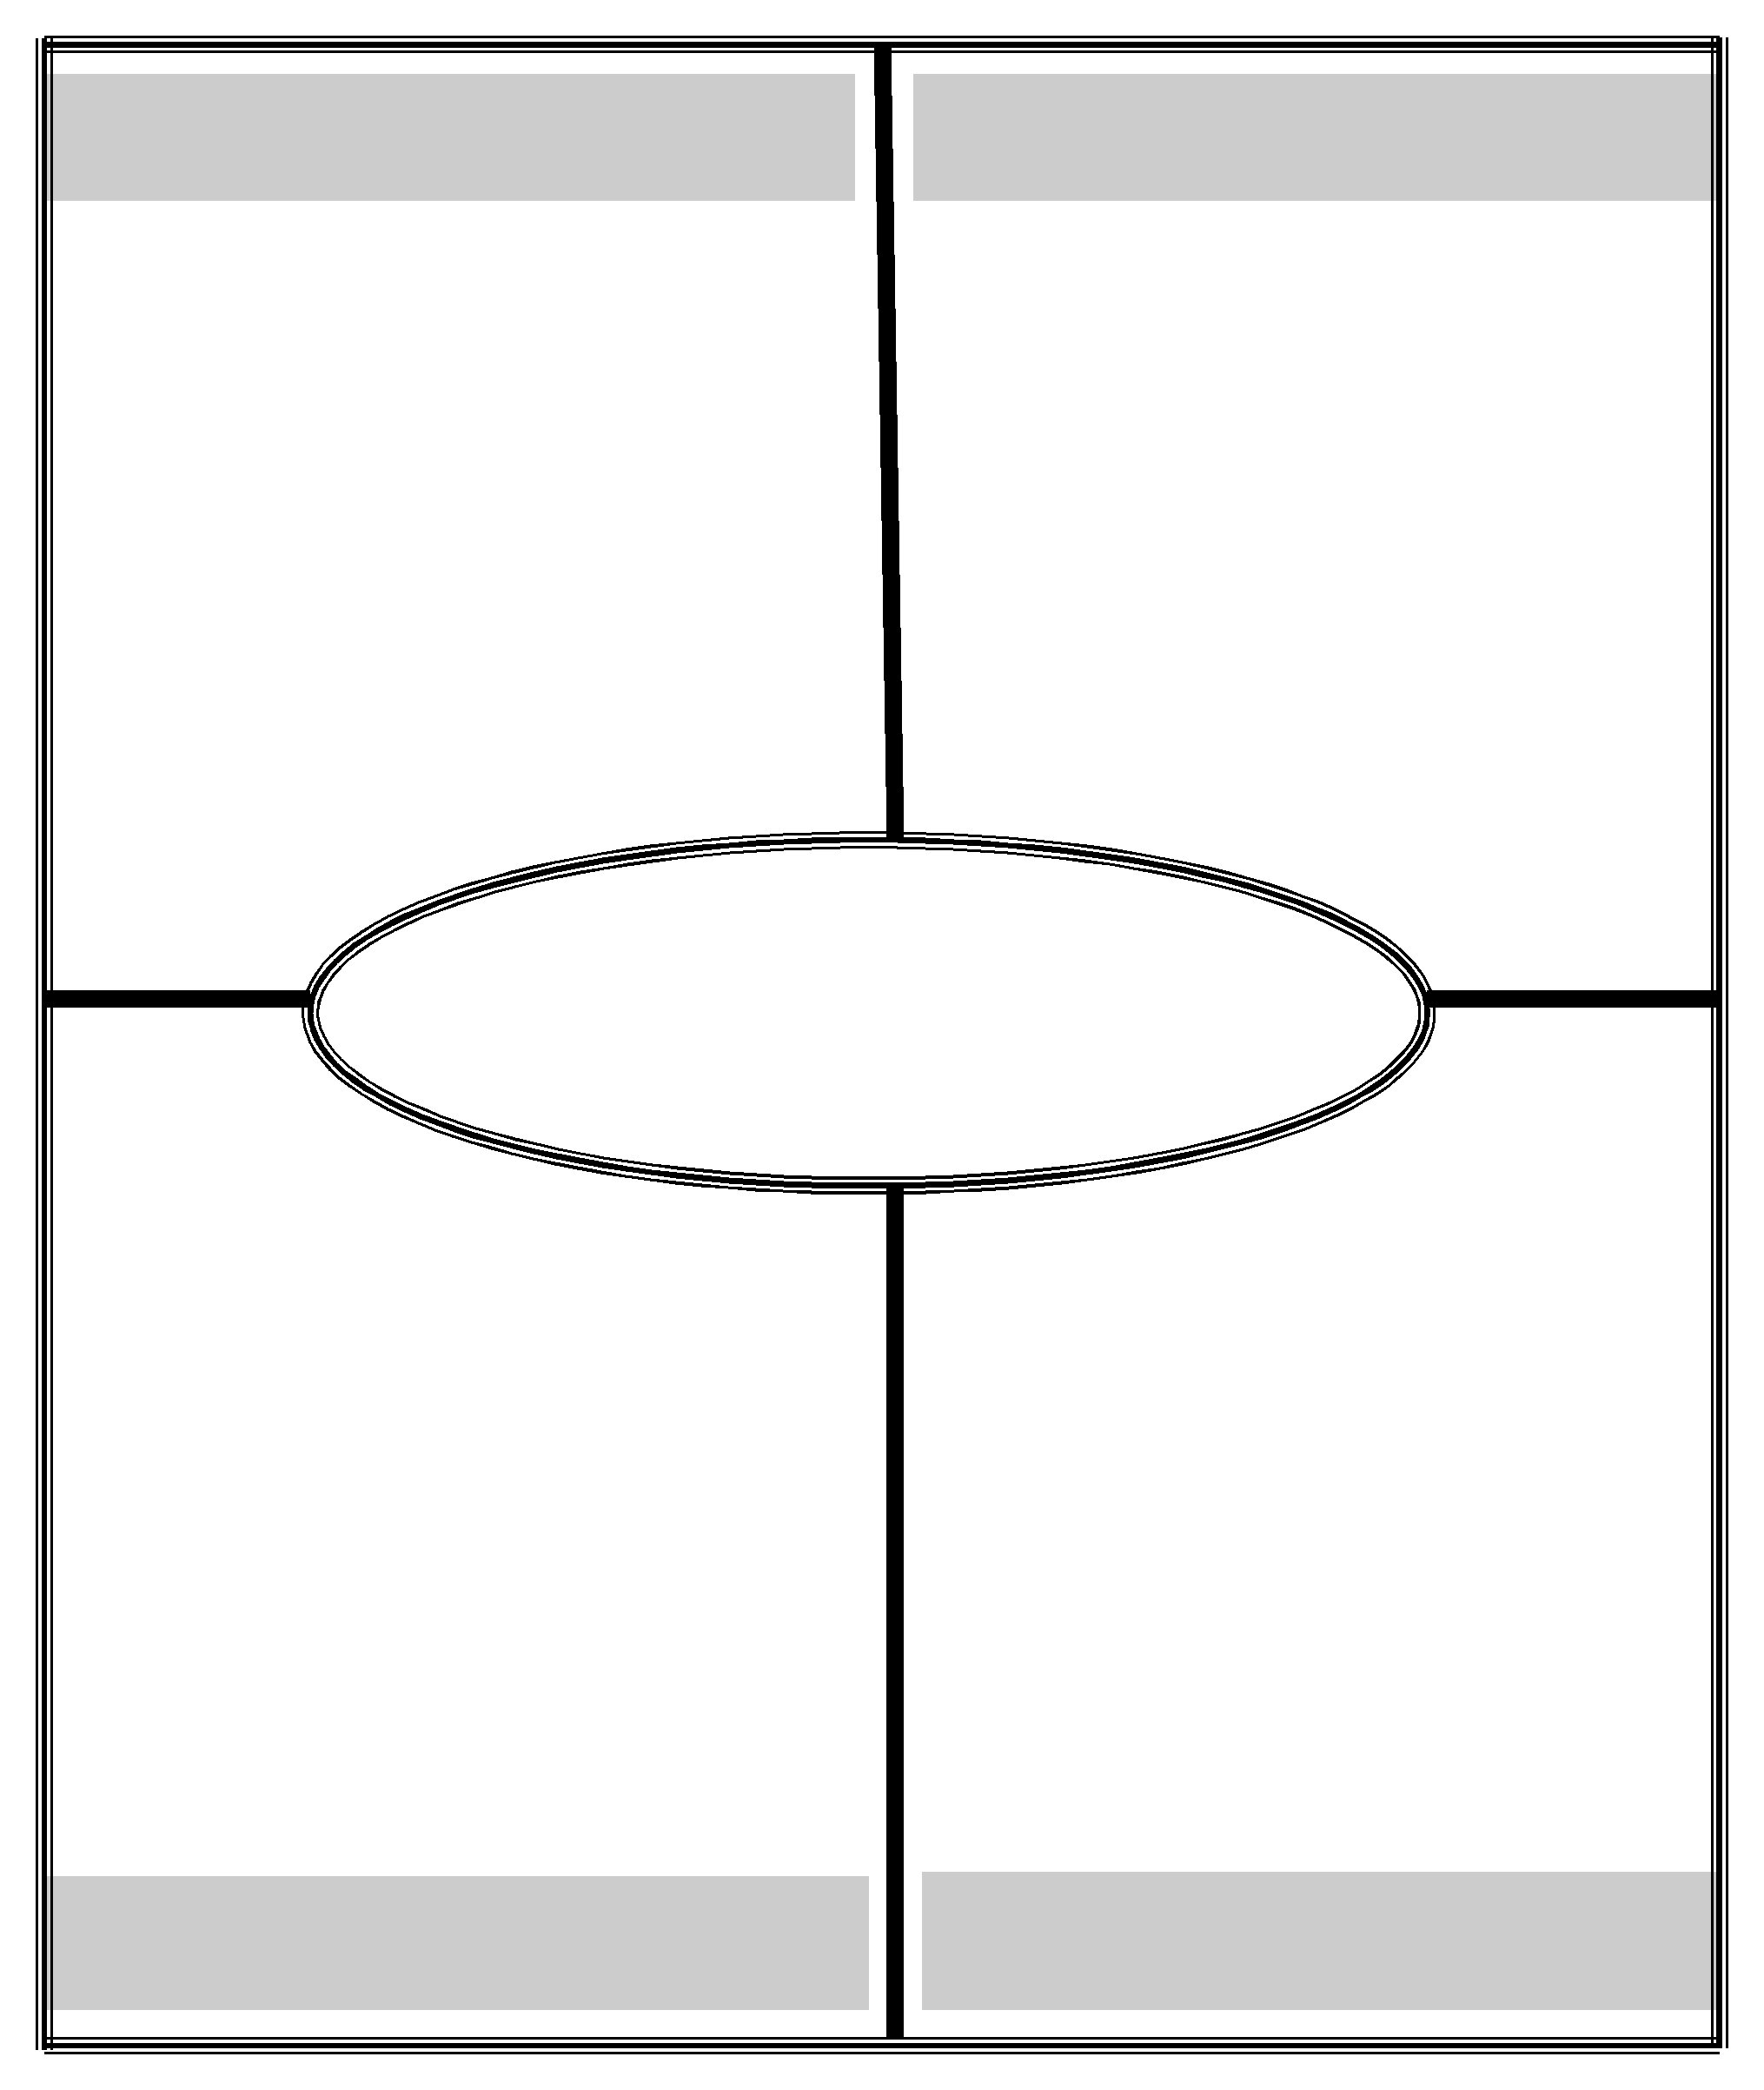
definition characteristics

lacking clear- | adjective- con-
ness or definite- | fusing; some-
ness; obscure; | thing that could
indistinct | go either way

ambiguous

an ambiguous | when some-
answer- not | thing is clear,
clear in meaning | precise, explicit

example non-example

2013-2014

Word of the Week
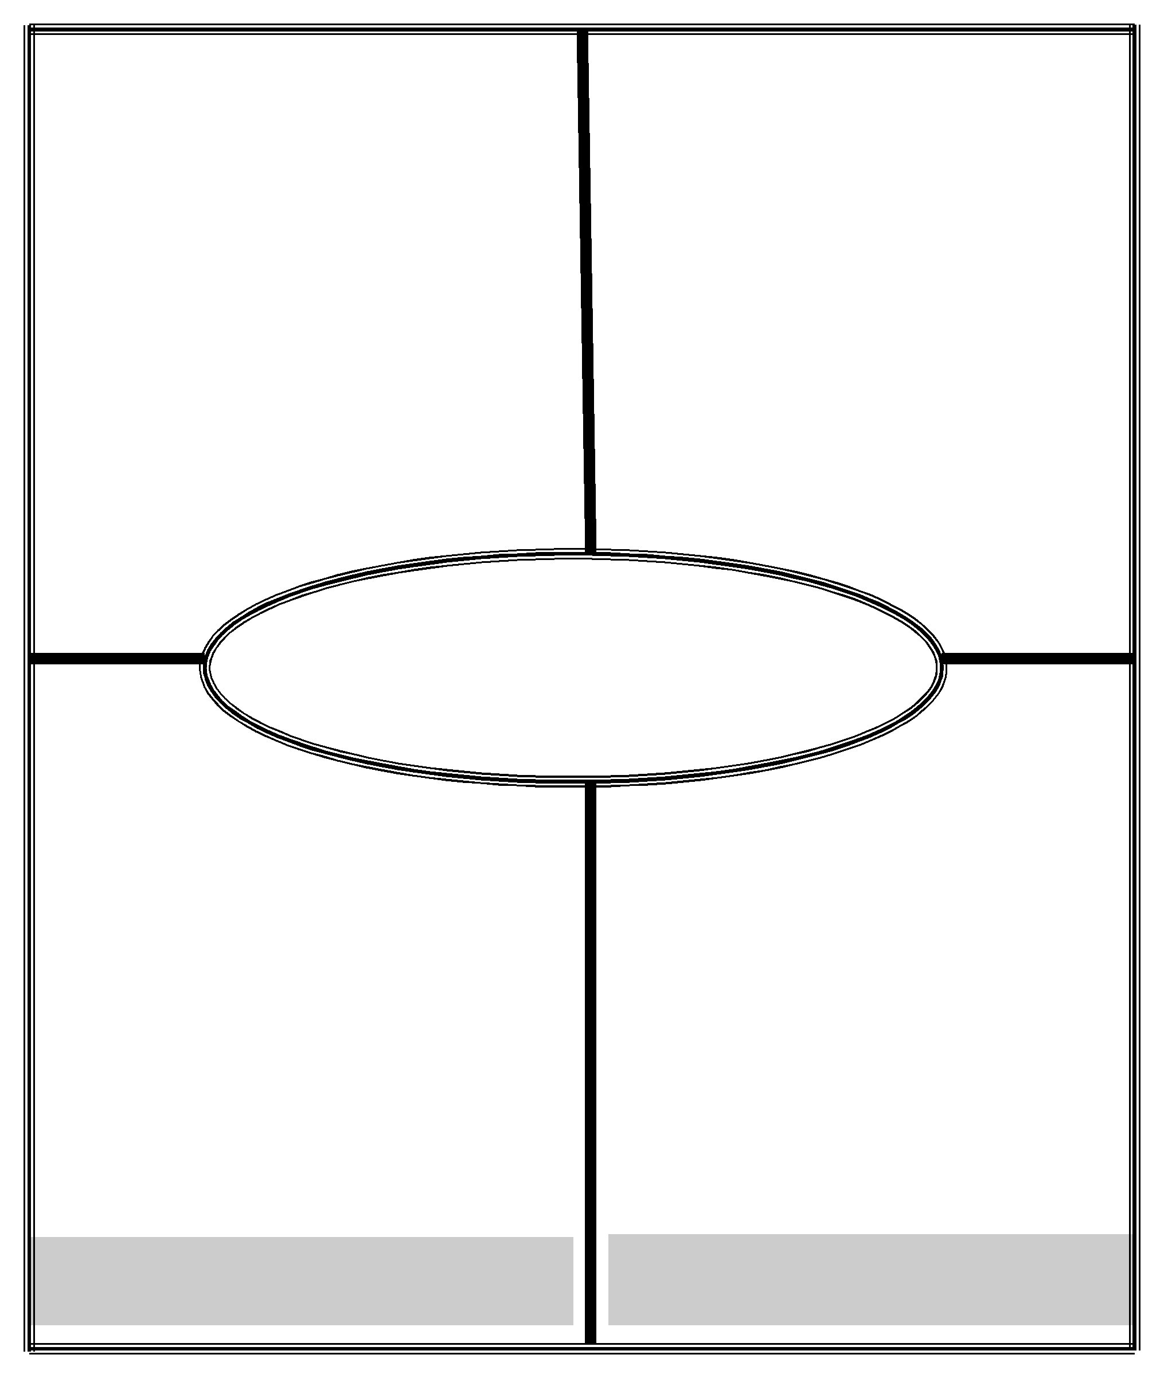
definition |  | characteristics
to examine care- |  | verb- separate
fully and in detail |  | into parts to
so as to identify |  | into parts to
so as to identify |  | study relation-
causes, key factors, |  | study relation-
possible results, etc. |  | ships

analyze

The teacher ana- | to syn-
lyzed the bench- | to syn-
mark results. | thesize

example non-example

2013-2014

Word of the Week
definition characteristics

to put into ac- | verb- putting
tion; to be ap- | something into
propriate for | use or request-
use | ing something

apply

He will ap- | not putting
ply to college | into action
next year. | or use

example non-example

2013-2014

Word of the Week

definition

an oral disagree-ment;a statement, reason, or fact for or against a point

characteristics

noun- discuss-ing with oppo-site points of view

argument

Mom and dad had an argument about whether or not I de-serve a new phone.

example

Everyone pleas-antly agreed to buy me a new phone.

non-example

2013-2014

Word of the Week
definition |  | characteristics
the group of |  | noun- the people
spectators at a |  | reached by a
public event; lis- |  | book; followers of
public event; lis- |  | a public enter-
teners or viewers |  | a public enter-
teners or viewers |  | tainer

audience

I wrote my es-say for a teen-age audience.

example

This essay is per-sonal and no-body will ever read it.

non-example

2013-2014

Word of the Week
definition characteristics

to arrange in classes or cartegories

verb- describe by labeling, sort things out, color -code items

categorize

Sammy cate- | Tommy's
gorized her | shirts are all
shirts by color. | mixed up.

example non-example

2013-2014

Word of the Week

definition

to examine (two or more objects, ideas, etc.) in order to note similarities and differences

characteristics

verb- associate things, find rela-tionships, iden-tify with, match

compare

I can compare | Organize by
how much two | different col-
sisters look alike. | different col-
 | ors

example non-example

2013-2014

Word of the Week
definition characteristics

to put together substances or parts in order to make or build

verb-build, cre-ate, make

construct

When trying to answer | to destroy,
a trivia question, people | to destroy,
construct a range of | bring apart
possible values based | bring apart
on their knowledge.

example non-example

2013-2014

Word of the Week
definition characteristics

to compare in | verb- differen-
order to show | tiate, discrimi-
unlikeness or | nate, distin-
differences | guish, oppose

contrast

Compare and | Looking for
contrast causes | Looking for
contrast causes | similarities
for extinction, | similarities
past and present

example non-example

2013-2014

Word of the Week
definition characteristics

to tell or depict | verb- portray,
in written or spo- | characterize,
ken words; give | represent; re-
an account of | count, tell, relate

describe

They will look at pic-tures of these animals and describe the simi-larities and differences in their appearances.

example

To narrate events in time.

non-example

2013-2014

Word of the Week
definition characteristics

to elaborate | verb- build,
or expand | form,
in detail | elaborate

develop

The ethmoidal cells begin to de-velop during fe-tal life.

example

Keeping a pro-ject at the brain-storming stage.

non-example

2013-2014

Word of the Week

definition

to perceive the difference in or between things

characteristics

verb- separate out two or more things, look at and under-stand what makes two things different

differentiate

When you can look at an original purse and a knockout and know the difference.

example

When you can pin-point the differ-ence between tw brands of jeans.

non-example

2013-2014

Word of the Week
definition characteristics

to divide into classes

verb- show the difference in things

distinguish

being able to iden- | All apples
tify the difference | All apples
tify the difference | are the
between oranges | are the
and tangerines | same.

example non-example

2013-2014

Word of the Week

definition

to judge or deter-mine the signifi-cance, worth, or quality of; assess

characteristics

verb- appraise, judge, decide, or estimate something

evaluate

The teacher re-views a paper to give it a grade.

example

Taking any kind of medication when you are sick.

non-example

2013-2014

Word of the Week
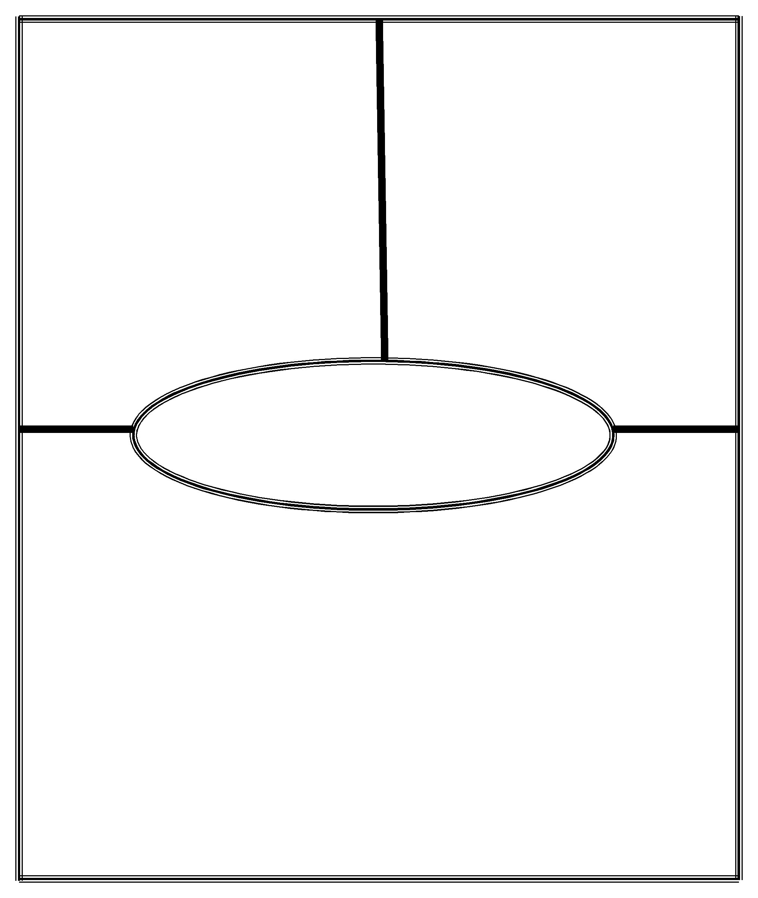
definition |  | characteristics
to make clear |  | verb- making the
the cause or |  | meaning of some-
the cause or |  | thing clear or un-
reason of; ac- |  | thing clear or un-
reason of; ac- |  | derstandable
count for |  | derstandable

explain

I cannot explain |  |  |  | providing no
his strange be- |  |  |  | reasons for a
havior. |  |  |  | particular be-
 |  |  |  | havior
 |  |  |  | non-example
example |  |  |  | non-example

2013-2014

Word of the Week
definition |  | characteristics
to set forth the |  | verb- to de-
opinions, feelings, |  | clare, indicate,
etc., of (oneself), as |  | clare, indicate,
in speaking, writ- |  | signify some-
in speaking, writ- |  | thing
ing, or painting |  | thing

express

He can ex- | He conceals
press himself | his feelings
eloquently. | well.

example non-example

2013-2014

Word of the Week

definition

to bing into existence; cause to be; produce

characteristics

verb- coming up with some-thing new, to create or make

generate

The office staff generated a list of students eligible for the pizza party.

example

not making anything or destroying

non-example

2013-2014

Word of the Week
definition characteristics

to recognize, | verb- distin-
to make, rep- | guish, place,
resent to be, or | know, deter-
regard | mine.

identify

As students look at the map, have them identify the city and some of its suburbs.

example

All cities can be found in all states.

non-example

2013-2014

Word of the Week
definition |  | characteristics
suggested without |  | adjective- to
being directly or |  | assume, in-
explicitly stated; |  | assume, in-
explicitly stated; |  | clude, signify
tacitly understood |  | clude, signify
tacitly understood |  | something

implied

Order is im- | Explicitly
plied in the exis- | Explicitly
tence of mathe- | stated
matical truths

example non-example

2013-2014

Word of the Week
definition |  | characteristics
to conclude or |  | verb- put clues to-
judge based on |  | gether, analyze
judge based on |  | what is not explic-
evidence and |  | itly said or writ-
good reasoning |  | itly said or writ-
good reasoning |  | ten

infer

The detective found a |  |  |  | Giving an opin-
fingerprint in the sus- |  |  |  | ion based answer
pect's room, so the |  |  |  | ion based answer
 |  |  |  | with no evidence
detective infers the |  |  |  | with no evidence
suspect is guilty. |  |  |  | to support it
 |  |  |  | non-example
example |  |  |  | non-example

2013-2014

Word of the Week
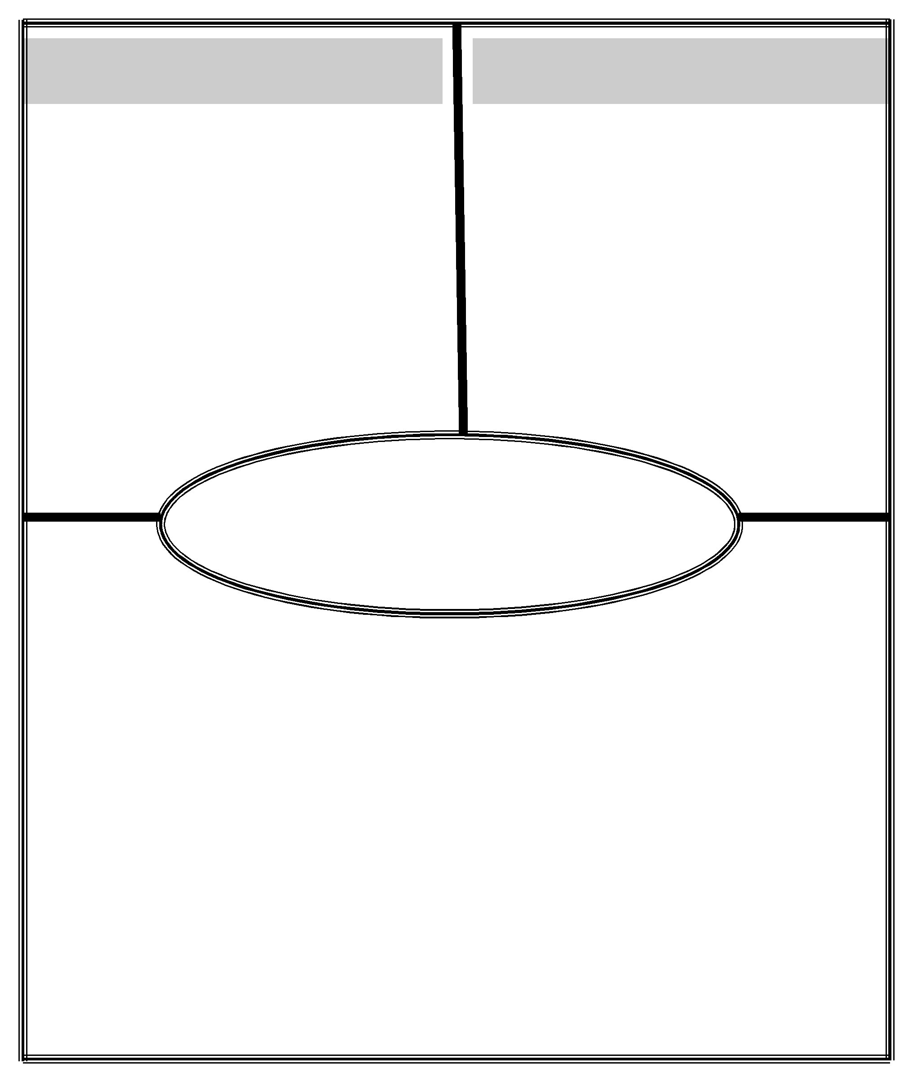

definition

the action or process of producing effects on the actions, be-havior, opinions, etc., of another or others

characteristics

verb/noun- in-cite, rouse, arouse, instigate, induce, persuade.

influence

Her mother's |  |  |  | Not letting any-
influence |  |  |  | body's words de-
 |  |  |  | termine your ac-
made her stay. |  |  |  | termine your ac-
 |  |  |  | tions.
 |  |  |  | non-example
example |  |  |  | non-example

2013-2014

Word of the Week
definition |  | characteristics
to bring out the |  | verb- to clar-
meaning of (a dra- |  | verb- to clar-
matic work, music, |  | ify or explain
etc.) by perform- |  | something
ance or execution.

interpret

How you define | I cannot get
words will impact | I cannot get
how you inter- | the meaning
pret combinations | of this.
of words. | of this.

example non-example

2013-2014

Word of the Week
definition |  | characteristics
the way that simi- |  | adjective- re-
lar or related texts |  | lationship be-
influence, reflect, |  | lationship be-
influence, reflect, |  | tween and
or differ from each |  | tween and
other: |  | across texts

intertextual

The intertextual- |  |  |  | not making con-
ity between two |  |  |  | nections across
novels with the |  |  |  | different texts
same setting.
 |  |  |  | non-example
example |  |  |  | non-example

2013-2014

Word of the Week
definition characteristics

to demon- | verb- giving an ac-
to demon- | ceptable reason or
strate or prove | ceptable reason or
strate or prove | explanation, provid-
to be just, | ing evidence and sup-
right, or valid | port for a decision

justify

The student justified | criticizing, re-
each budgetary ex- | tracting or tak-
pense as necessary in | tracting or tak-
pense as necessary in | ing back what
her Math homework. | ing back what
her Math homework. | you said

example non-example

2013-2014

Word of the Week
definition characteristics

to sys-tematize

verb-to form a whole from in-terdependent parts

organize

I organized the |  |  |  | The filing cabinet
files from my |  |  |  | contains papers
teacher's cabi- |  |  |  | that are all mixed
net. |  |  |  | up.
 |  |  |  | non-example
example |  |  |  | non-example

2013-2014

Word of the Week
definition characteristics

convincing,

compelling, forceful

adjective-able, fitted, or in-tended to con-vince

persuasive

Her argument | Opinions are not
was so persuasive | persuasive if they
the judge ruled | are not sup-
in her favor. | ported by facts.

example non-example

2013-2014

Word of the Week
definition |  | characteristics
to declare |  | verb- to know or
to declare |  | tell (usually cor-
or tell in |  | tell (usually cor-
or tell in |  | rectly) before-
advance |  | hand what will
advance |  | happen

predict

Satellite data is the only way to predict storms

example

I already know we will have a test this Friday because the teacher told us.

non-example

2013-2014

Word of the Week
definition |  | characteristics
comparative rela- |  | noun-
tion between |  | comparison,
things or magni- |  | share, distribu-
tudes as to size, |  | tion, arrangement
quantity, number,

proportion

The amount of power generated increased in proportion to the number of drop-lets used.

example

The absolute amount of some-thing compared to nothing but itself.

non-example

2013-2014

Word of the Week

definition

The relation be-tween two quanti-ties expressed as the quotient of one di-vided by the other

characteristics

noun- per-centage, cor-relation, rate

ratio

The staff/student ra- | Something
tio at our campus is | Something
great compared with | represented
an average 1:45 in | as a whole.
many foreign schools. | as a whole.

example non-example

2013-2014

Word of the Week
definition characteristics

to identify from | verb-
knowledge of | acknowledge, ap-
knowledge of | preciate, under-
appearance or | preciate, under-
appearance or | stand, grant, con-
characteristics | stand, grant, con-
characteristics | cede.

recognize

I recognized | Not accepting the
I recognized | need for some-
him from the | need for some-
him from the | thing, or unable to
description. | identify something

example non-example

2013-2014

Word of the Week

definition

to bring into or establish asso-ciation, connec-tion, or relation

characteristics

verb- to tell, re-port, or describe in some detail an occurrence or cir-cumstance

relate

Insufficient con-sumption of wa-ter is directly re-lated to fatigue.

example

Hypnosis can be used to relax and calm and then dissociate you from the situation giv-ing rise to the anxiety.

non-example

2013-2014

Word of the Week

definition |  | characteristics
a decision or |  | noun- resolve, de-
determination; |  | termination, per-
determination; |  | severance, tenac-
a resolve |  | severance, tenac-
a resolve |  | ity; strength, for-
 |  | titude

resolution

The terms of any delegation should be approved by a reso-lution of the board.

example

I cannot find a solution to my problem.

non-example

2013-2014

Word of the Week

definition

to make less complex or com-plicated; make plainer or easier

characteristics

verb-to make less compli-cated, clearer, or easier

simplify

To simplify a problem.

Gaby reduced the fractions into simpler form.

example non-example

2013-2014

Word of the Week

definition

to tell or write briefly about the main ideas in a selection

characteristics

verb- it is short, it includes only the most im-portant details

summarize

To explain |  |  |  | retelling every
what happened |  |  |  | detail in every
in a movie |  |  |  | chapter of a
 |  |  |  | book
 |  |  |  | non-example
example |  |  |  | non-example

2013-2014

Word of the Week

definition characteristics

to combine (a | verb- combin-
number of | ing to form a
things) into a | new, complex
coherent whole | product

synthesize

The movie syn-thesized years of sports' history.

example

including all the details, informa-tion or parts of something

non-example

2013-2014

Word of the Week

definition characteristics

example non-example

2013-2014

Word of the Week
definition characteristics

example non-example

2013-2014

